Games
IMPORTANT Parent or Carer –
Check that you are happy with any weblinks or use of the internet.

NB New activities are being added at the top of each document.

Activity 12 – Hand and eye games
Create and play a target game

What to do  - Explain that you are going to create a target game. Your balls will be rolled up socks and the target will be the laundry basket.  - Roll up the socks and place the basket on a mat (or similar).  - Decide on the score for getting a sock in the basket and a lower one for landing just outside on the mat (start with 2 points for the basket and 1 point for the mat).  - Play the game, taking turns to throw the socks and then working out the score by counting the socks.  - Who has scored the most points? | What you need  Rolled up socks  Laundry basket and a mat  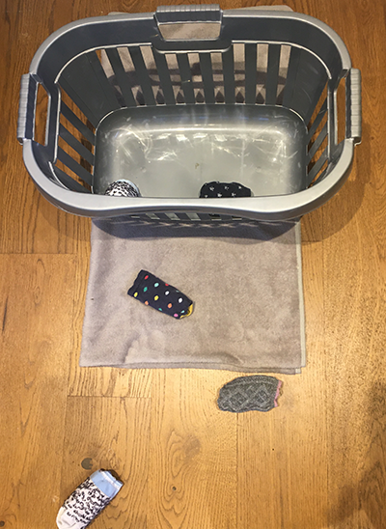
Extension  Try counting in 2s for the socks in the basket to make the counting quicker.  Try counting the basket and mat landing socks separately and then adding up the total score.  Raise the basket score to 10. Can you count the score by counting in tens? | Questions to ask  How many throws should each person get?  What will we score if we get a sock in the basket?  How many socks are in the basket? How many points is that?  What is my score altogether?  Can we count in twos/tens?

Activity 11 – Race games
Play ‘Flapping Fish’

What to do  - Cut out a large fish shape from a single sheet of newspaper for each player.  - Make paper fans from a second piece of newspaper, again for each player, by folding it in thin zigzags until you have a folded fan.  - Lay the fish on the floor and explore making them move by fanning them. You can try different fanning techniques to see which has most effect.  - Line up your fish and have a race. First fish past the post wins! | What you need  Newspaper and a hard floor  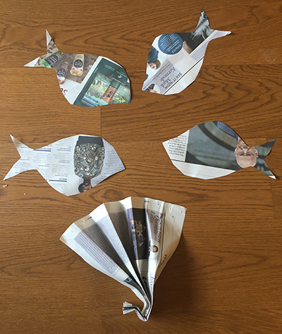
Extension  Make the game a time challenge. How quickly can you fan the fish to the chair and back?  Include some very simple obstacles into the race.  Change the type of fan. Try different shapes, different papers or a balloon pump. | Questions to ask  How can we make a fish shape?  Can we make a paper fan by folding?  Can you feel the air move when you flap the fan?  Can we make the fish move without touching it?  What is moving the fish?  Who will win the race?

Activity 10 – Memory games
Play ‘I went to the shops’
What to do  - Explain that you are going to play a game which will test your memories!  - Start with the phrase, ‘I went to the shop…’ and finish it with something that you can buy. Keep it simple at this point, e.g. ‘I went to the shop and I bought an apple.’  - The next player has to repeat the first sentence and then add a second thing that you bought, e.g. ‘I went to the shop and I bought an apple and a loaf of bread.’  - The game continues with each player adding one item to the string. It is fine to give clues and add actions to support the remembering.  - The list items tend to get more outlandish as you play.  - When the list becomes too long to remember, restart it with a new list. | What you need  Nothing needed
Extension  Make the shop specific, e.g. a bakery.  Make the game about a different place, e.g. ‘I went to the zoo/farm/beach and I saw a…’  Play with several people or over a video call. | Questions to ask  Can you repeat my sentence and add one more thing?  Can you remember all the items?  What else could you buy?  Can you remember…? It was something you draw with.

Activity 9 – Acting games
Play animal charades

What to do  - Cut out the Charade cards – see below.  - Look at each picture and read the labels together.  - Say it would be fun to play a guessing game called charades.  - Explain the game, saying that players take turns to pick a card and pretend to be that animal.  - Fold the cards and put into a cup or basket.  - Take one and look at it, explaining that this is a secret. Act out the animal silently through movement. Can anyone guess which animal you are?  - When you have been correctly identified, someone else has a turn. | What you need  Charade cards (see below)  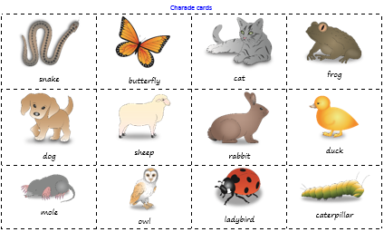
Extension  Make the game easier by giving clues or asking questions. ‘This animal eats grass.’  Make new cards together with a different topic, e.g. Underwater creatures, or types of job. | Questions to ask  What animals are on these cards? Can we read the labels? Which is your favourite?  Can you guess which card I have chosen?  Which animal moves like this?  Am I getting close with my guesses?  Whose turn is it now?

Charade cards
snake | butterfly | cat | frog
dog | sheep | rabbit | duck
mole | owl | ladybird | caterpillar

Activity 8 – Board Games
Create and play a board game
What to do  - Talk about any board games that you like to play. Discuss how you move around the board (often using a die) and some squares have actions associated with them (e.g. snakes and ladders).  - Say it would be fun to make a new game based on snakes and ladders.  - Together plot out a linear route of squares with a starting and finishing point. You can number the squares or show the direction with arrows.  - Talk about what things might make a player miss a turn or go back a space and what might propel them forward. (muddy puddles and gusts of wind, banana peel and springs, etc.). Mark some of the squares with these.  - Test the game to check that it is fun to play. You might add a few other features such as a challenge square (do 10 jumping jacks or an impression of a firework, etc.). | What you need  A large sheet of paper  Small figures to act as counters  Felt pens  A die (or a coin if you don’t have one: heads= 1 space, tails=2 spaces)  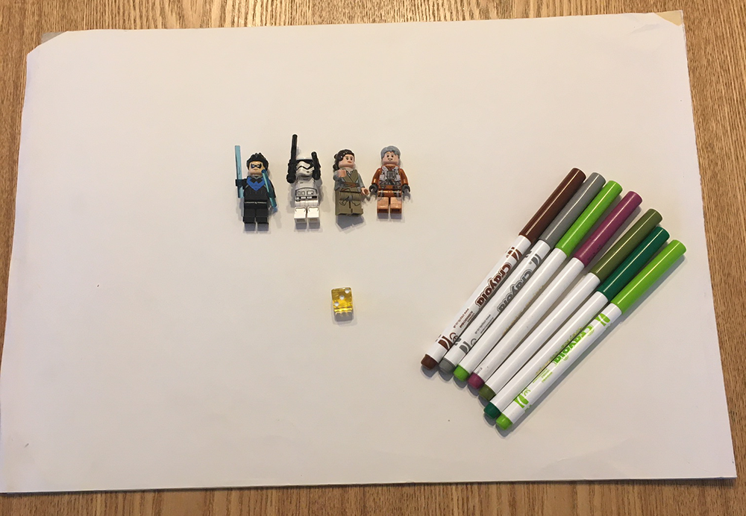
Extension  Give the game a brilliant name.  Add colour and pictures to the gameboard.  Play the game with your household, enjoying the design.  Post it to faraway family/friends as a gift (send a copy if possible). | Questions to ask  What board games do you like to play?  How do they work? What are the rules?  Could we design our own game?  How will players move around the board?  What will make the players move back or get a boost?  Who will enjoy playing our new game?

Activity 7 – Memory games
Play ‘Kim’s Game’

What to do  - Talk about the 10 things that are on the tray. Count them together and agree that there are 10.  - Explain that in a minute you are going to ask your child to cover their eyes while you take one away. They will have to use their memory to spot which object is missing.  - Give them 20 seconds to memorise the objects.  - Take one of the objects away while your child is not looking. Can they work out which is missing? They might guess several things that are still on the tray before arriving at the missing one.  - Swap roles and play again. | What you need  A tray  10 different items that will fit on the tray  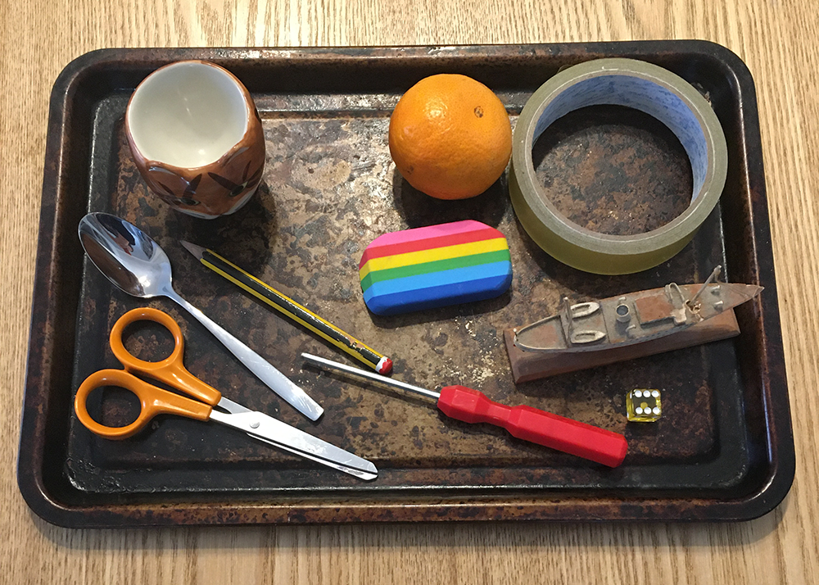
Extension  Make it easier with less objects.  Make it easier by giving clues, e.g. It’s yellow.  Make it harder by moving all of the objects around before removing one.  Take two objects away at a time. | Questions to ask  How many objects are on my tray? Can you count them?  Can you memorise which objects are on the tray?  Can you spot which one is missing?

Activity 1 – Hand games
Play ‘Rock, Paper, Scissors’

What to do  - Talk about how to play the game, practising the different hand shapes, what they are called and how they interact.  - How to play:  - On the count of three, both players make one of three shapes with their hands: rock, paper or scissors  - Scissors cut paper = scissors win  - Paper wraps rock = paper wins  - Rock breaks scissors = rock wins  - If you show the same object it is a draw  - Play the game, facing each other and trying to get the highest score. | What you need  Someone to play with…  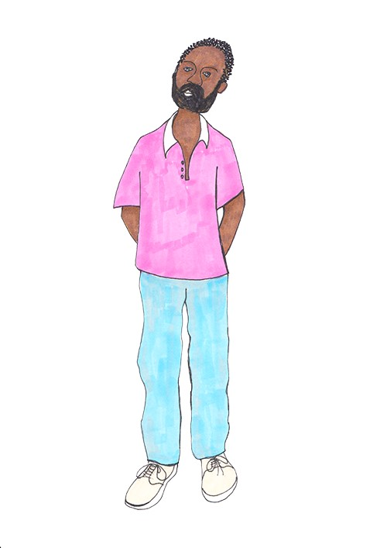
Extension  Discuss which shape is the best to win (none – although most will say rock).  Keep a tally to keep score.  Play remotely over video call. | Questions to ask  What three shapes can we make with our hands?  What happens if you show scissors and I show paper?  Who won that round?  What is the score so far? Who is winning?

Activity 2 – Hand games
Play ‘Guess which hand’

What to do  - Show the object in one hand with the empty hand next to it.  - Close both hands and put them behind your back. At this point you can either keep the object where it is or swap it to the other hand.  - Bring both closed hands back in front and ask your child to guess which hand the object is in.  - You can make this more fun by letting them feel your hands, look into your eyes for clues and watch your reaction as they look at one of the hands.  - Your child guesses and then you open that hand to reveal if they were right. | What you need  A small object which fits in the hand (could be a coin, sweet or small toy)  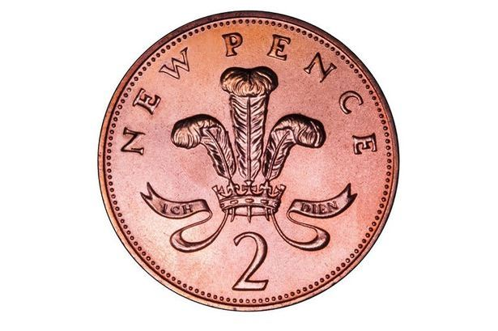
Extension  Swap roles, with your child doing the hiding.  As your child becomes more confident, introduce the idea of bluffing, exaggeratedly reacting when they look at the wrong hand – your child will love tricking other adults.  Play remotely over a video call. | Questions to ask  Can you see which hand it is in?  Have I swapped hands or not? Can you tell?  Can you work out which hand the coin is by looking closely at my hands/feeling them/ looking into my eyes?  Can you tell if I am bluffing or not?

Activity 3 – Hand and eye games
Play ‘Pick up sticks’

What to do  - Hold the sticks in one hand, upright with one set of ends touching the surface.  - Release them gently by opening your hand. You want to end up with the sticks in a loose pile, touching each other.  - The idea of the game is to take turns picking up one stick at a time, without moving any of the others.  - If you can pick up a stick without disturbing any others, you can keep it. If not, you return it to the pile. | What you need  Collect a large handful of thin, straight-ish sticks (at least 20).  (It is possible to buy packs from toyshops.)  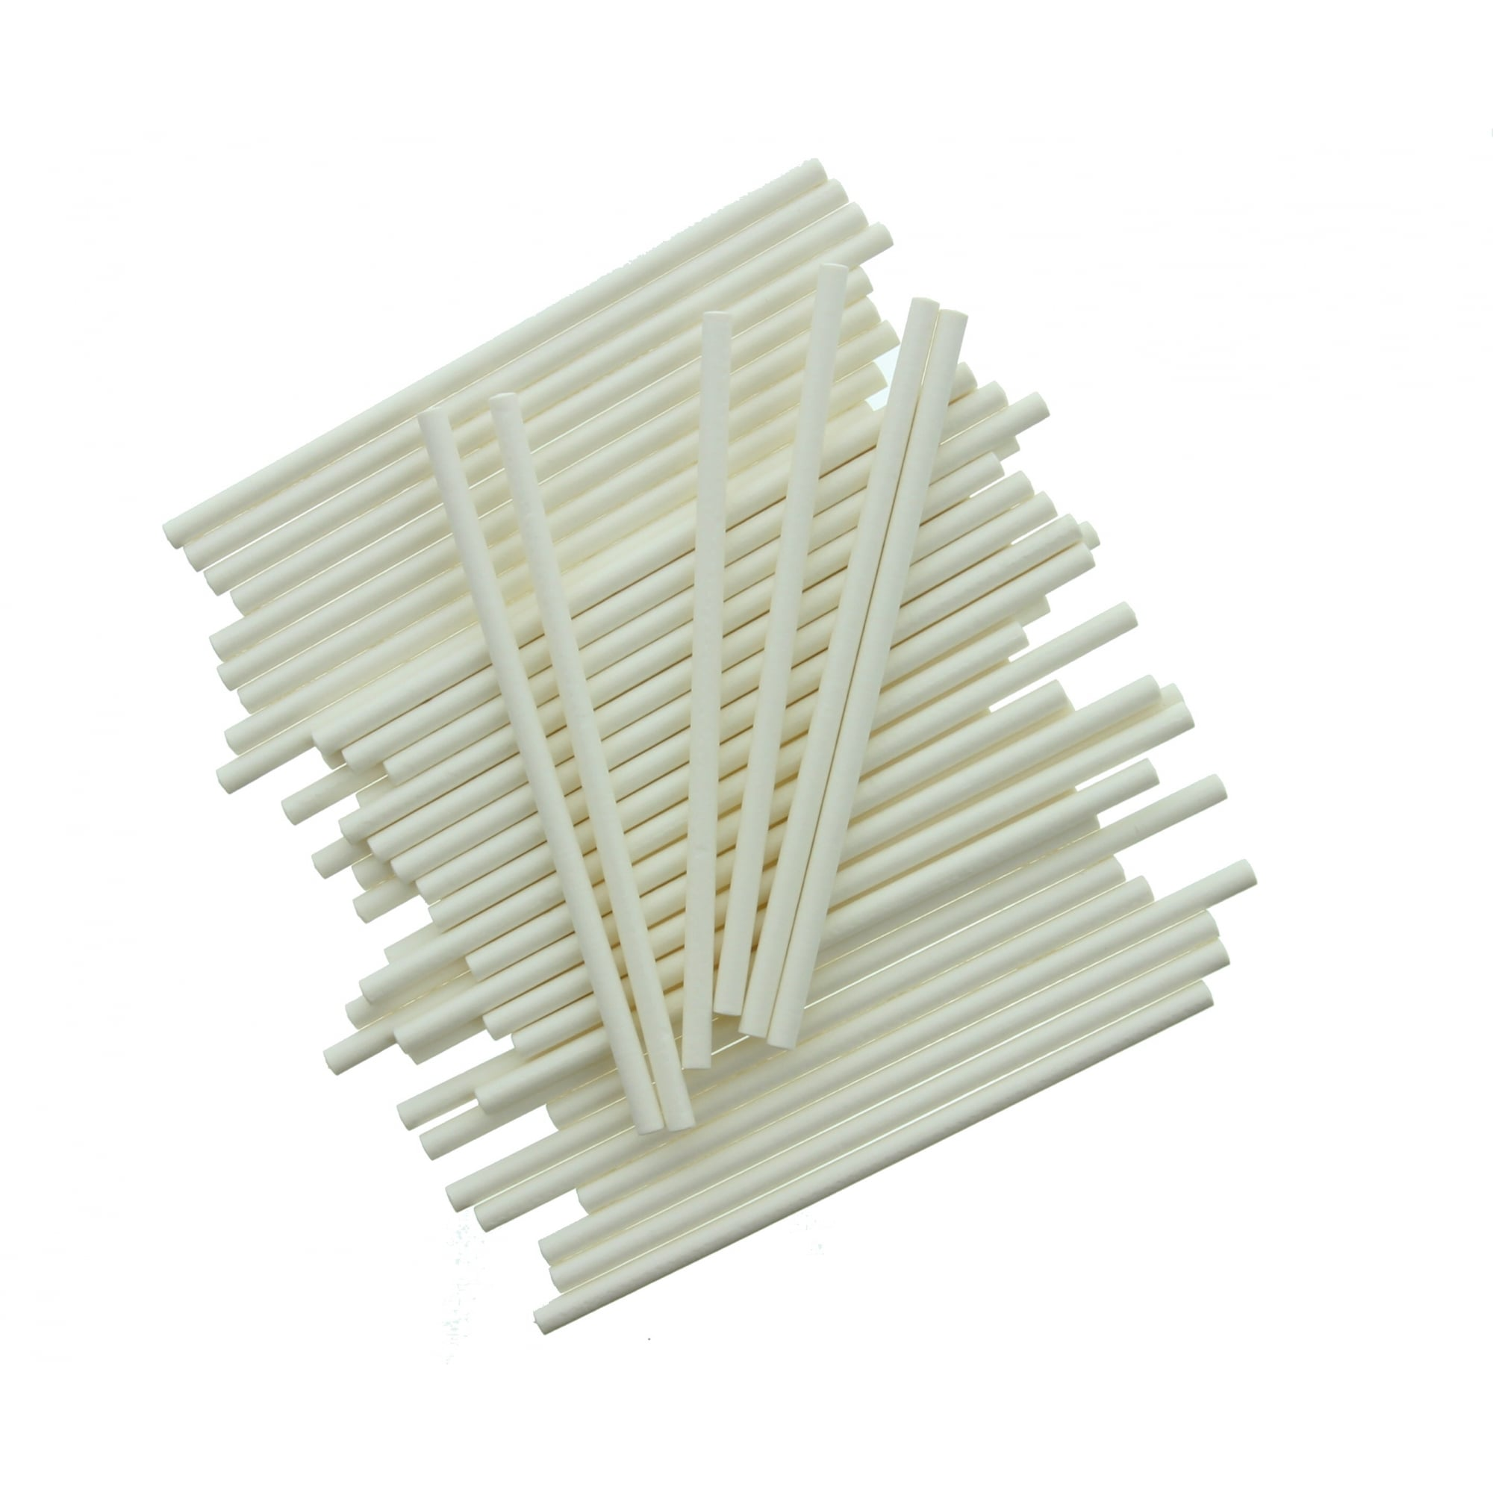
Extension  Keep score by counting sticks won.  Make each stick worth 2 points – how many points do you have now?  Increase the number of sticks in play.  Try playing with your non dominant hand. | Questions to ask  Can you pick up that stick without touching any others?  Which stick would make a good one to start with?  How can you choose which stick is best?  What would make the game harder?  How many sticks have you got?  What is the score? Who is winning?

Activity 4 – Pen and paper games
Play ‘Noughts and crosses’

What to do  - Draw out the grid (3x3) on paper.  - Decide who will play noughts and who will play crosses.  - Explain that the winner is the one who can get three of their symbols in a row.  - Take turns to play.  - Now your child can make some pictures arranging the shapes and sticking them down when they are happy with their position. | What you need  Paper and pencil  Or chalk and pavement  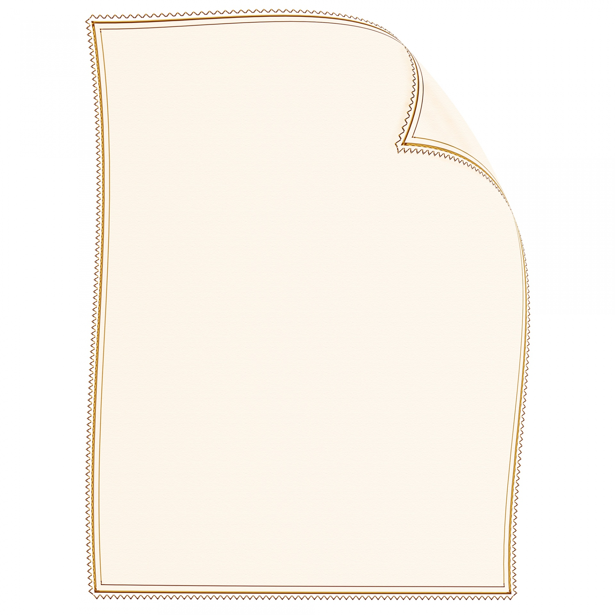  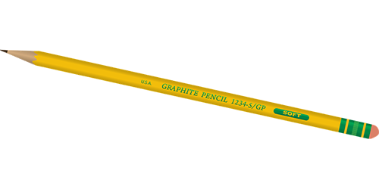
Extension  Keep score as a tally.  Increase the size of the grid (4x4, 5x5, etc.) and the number in a row needed to win.  Play on a chalk-drawn grid, using objects as counters, e.g. daisies vs leaves. | Questions to ask  Who will play crosses?  How many do we need in a line to win?  Which is the best square to choose first?  Can you see how to block my line?  Who is winning?  Who has the highest score?

Activity 5 – Pen and paper games
Play ‘Heads, bodies and legs’

What to do  - Pre-fold each piece of paper into three equal folds so that when you unfold it there are three creases across the page.  - Each player draws a head in the top section, drawing a neck right down to the crease. They then fold the paper over so that the head is hidden.  - Pass the papers round and everyone draws a body for a different head (they cannot see the head they are drawing for). They draw the body with the lines coming down to the crease and then fold this over again.  - Pass the papers round once more and draw the legs and feet.  - When finished, pass the papers once more and unfold to reveal the funny pictures. | What you need  Paper (one piece for each player) and pencils  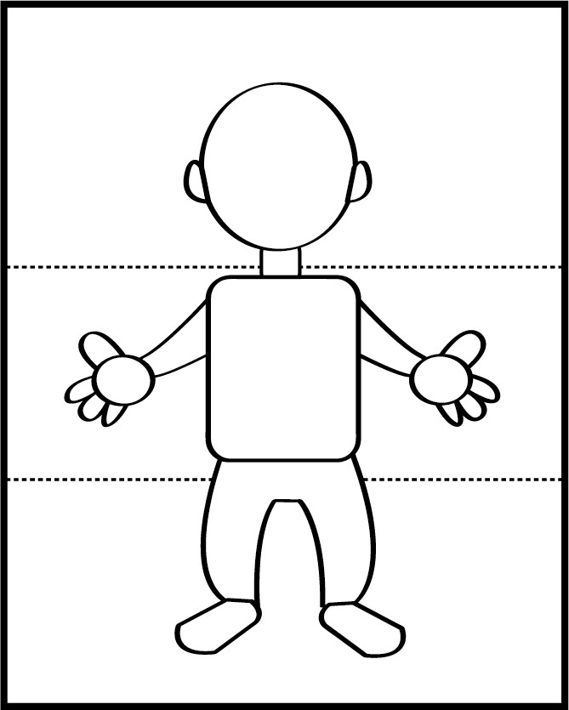
Extension  Name and colour in the pictures and make a collection of crazy characters. Talk about what they look like.  Draw aliens, fantasy characters, fairy-tale characters etc.  Make a set of funny people by drawing head, body and legs which match, cutting along the creases and rearranging. | Questions to ask  Can you draw a head and neck? Have you drawn the neck right down to the crease?  What sort of body will your picture have? What are they wearing? How many legs will your picture have? Are they human legs or a different animal?  What does your picture look like? Is it funny?  What shall we call this one?

Activity 6 – Hand and eye games
Play ‘Which cup?’

What to do  - Start with 3 cups in a row. Show that they are empty and place them upside down on the table.  - Place a small object under one cup and tell your child to keep their eye on the cup.  - Make a show of sliding the cups round, encouraging your child to keep their eye on the cup containing the object.  - When you have shuffled the cups around, ask your child to point to the cup containing the object.  - You can play the game with several guessers watching. | What you need  Three identical cups which will be easy to slide around  A small ball, bead or toy  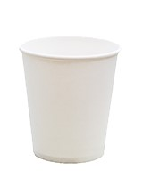  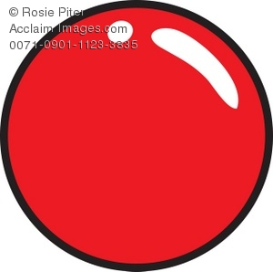
Extension  Play the game with more than one child by placing an object for different children to watch for (e.g. yellow pompom under cup 1 and green pompom under cup 2).  Ask your child to be the cup mover. Can they catch you out?  Keep score – a correct guess ends in a point for the guesser; an incorrect guess scores a point for the cup mover. | Questions to ask  Can you see the ball under the cup before I cover it up?  Can you keep your eye on the cup while I move them around?  Do you know which is your cup?  Can you catch me out?

