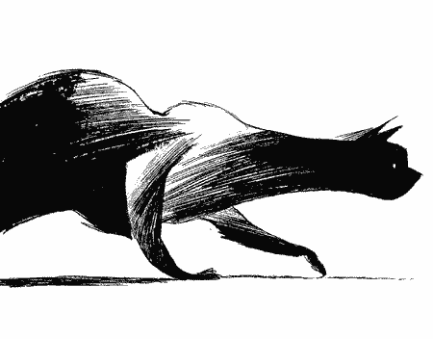
Varjak Paw
By S.F. Said

Presented by
Mr Wickins Reads!

Activity book

Name:_________________________

Varjak Paw
Chapter 1

Write the definition of the following words on the other side of this sheet

*Stealthy *Embarrassment *Stalk
*Pedigree *Proper *Identical
*Scoff *Dull

- Who is Jalal? What did he do?

- Who lives in the Contessa’s house with Varjak?

- How is Varjak treated by his family? Give an example to support your answer.

- How does the author describe the strangers who enter the Contessa’s house?

- Who are the monsters that live outside?
Varjak Paw
Chapter 2

Write the definition of the following words on the other side of this sheet.

*Scorch *Swish *Stylishly
*Groomed *Ripple *Rarest
*Munching *Flourish *Anxious

- Varjak’s family doesn’t believe Varjak when he tells them about the Gentleman and his cats. Describe a time when someone didn’t believe what you were telling them. How did it feel? What did you do?

- Predict what you think Elder Paw will say at the family meeting (If you already know what he said, then try and answer why you think he said it)

- What gifts does the Gentleman give the cats?

- What do you think the gentlemen took from the Contessa’s room?

Varjak Paw
Chapter 3 - 4

Write the definition of the following words on the other side of this sheet.

*Antique *Noble *Revolting
*Crackle *Impressionable *Rumble
*Absurd *Murmur *Scorn

- What are the three secrets Elder Paw tells Varjak? Describe what you think they are.

- How does Father Paw react to Elder Paw’s warning?

- Why does Elder Paw dislike the Gentleman?

- How could a dog help the cats?

- How does the author make the two black cats seem mysterious and dangerous?

Family Council Meeting

Reasons to stay inside:

Reasons to go outside:

Chapter 5
Head vs Heart
Why should Varjak have stayed in the garden?

Why should Varjak have left the garden?

Chapter 5-6
Outside! For the first time since Jalal, a Paw stood on the edge of the world... Varjak could see for miles and miles...
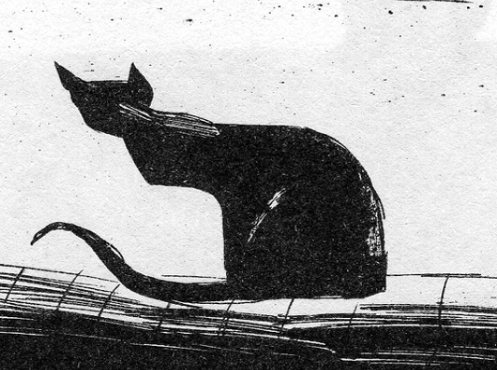
Draw what Varjak could see from the top of the wall. You can make it black and white, like the illustrator, by using dark pencil, black colouring pencil, charcoal or black felt tips.

Varjak Paw
Chapter 15-16

Draw a map of the city Varjak is located in… Make sure to include the park, Ginger’s territory, Sally’s territory, the city square where the pigeons are, the Contessa’s house on the hill and where the Vanishings occur.

Varjak Paw
Chapter 15-16

- Why did Ginger’s gang attack Varjak?

- Why is everyone afraid of Sally and her gang?

- In chapter sixteen, how did Varjak find his breakfast? Describe in detail.

- Why did Holly save Varjak?

Varjak Paw:
Chapters 27-28

Write the definition of each word on the other side of this sheet. Then write it in a sentence.

*Explain *Armchair *Sting *Thunder *Gnarled
*Climb *Powerful *Curtains *Corridor *Nudge

- How did Varjak recognize his house?

- Why doesn’t Cludge follow Varjak into his home?

- What is different about the cat door at the Contessa’s house?

- What does Varjak think of his old home?

- Who is the head of the family now?

- How does Varjak’s family react when he tells him the two black cats killed the Elder cat? Why do they react this way?

Make a chart to illustrate the seven skills in the way of Jalal:
Open Mind, Awareness, Hunting, Slow-Time, Moving Circles,
Shadow walking, Trust Yourself.

Varjak Paw:
Chapters 31-32

Write the definition of each word on the other side of this sheet. Then write it in a sentence.

*Failure *Restored *Knowledge *Noble
*Shimmer *Prickle *Merge *Cower

- What is the seventh skill? How does it work?

- What does it mean to be a true Mesopotamian Blue?

- How is Varjak like Jalal?

- Why does Varjak’s family not help Varjak?

- How does Varjak get past the black cat on the stairs?

- Describe what Varjak sees upstairs in five or more sentences.

- What does the Gentleman do to the cats?

Chapter 34
So far, the book has been written from Varjak’s viewpoint. Now, you are going to write from Cludge’s viewpoint.
Sketch and annotate or write your version of the ending in three different sections:
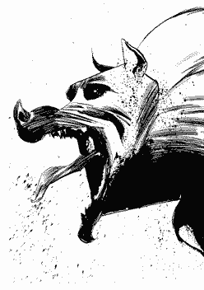
Part 1 – Outside the wall

Part 2 – Crashing through the window

Part 3 – How it all ends

