Art Activities
IMPORTANT Parent or Carer –
Check that you are happy with any weblinks or use of the internet.

NB New activities are being added at the top of each document.

Activity 12 – Art using natural and found objects
Make a stick person or animal

What to do  - Enjoy reading, watching or listening to Stickman by Julia Donaldson (see below for links if you don’t have the book).  - Look at the twigs you have collected and talk about a person or animal you could make, e.g. Stick Man, Stick Lady, Stick Dog, Stick Horse etc.  - Create the character together, fixing the twigs by wrapping them with string at 90° angle to make cross shapes).  - Add other features like eyes, hair, clothes etc. using leaves, grass, yarn, fabric and any other trimmings.  - Take your stick character on an adventure! | What you need  Twigs, string, leaves, grass  (Optional) fabric, eyes, yarn, glue and / or tape  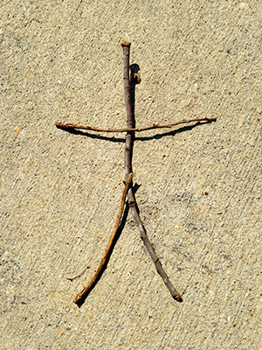
Extension  Try making a family of stick characters.  Make up stories about your character.  Make a scene using your character and other found materials, e.g. on the beach, by a river. | Questions to ask  What different materials have we got?  What sort of character could we make?  How many legs/arms/wings will we need to make?  How can we fix the parts together?

Watch on iPlayer https://www.bbc.co.uk/iplayer/episode/b06t09rk/stick-man
Listen to story being read by Julia Donaldson https://www.youtube.com/watch?v=o3lCfKhsOsY
Activity 11– Drawing and painting
Make a playdough dinosaur (or monster)

What to do  - Lay out all of the materials and talk about the different colours, textures and shapes.  - Talk about what sort of dinosaur you could make. It doesn’t have to be a realistic one. This is a chance to use our imaginations.  - Encourage lots of play, shaping, rolling, pinching and making marks with tools.  - When your child is happy with the basic shape, they can start to add decorative features.  - Give your dinosaur a name and take a photo for posterity. | What you need  Playdough & dough tools (or a table knife, rolling pin, fork, etc.)  Any decorative things, such as:  dried pasta shapes, wiggly eyes, feathers, pipe cleaners, lolly sticks, matchsticks,  sequins, buttons, etc.  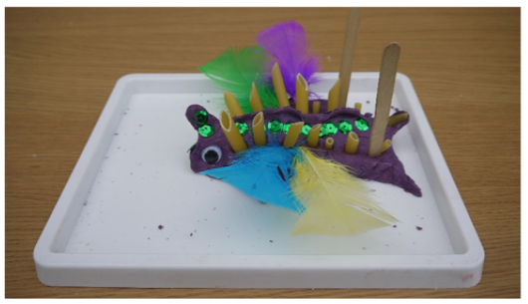
Extension  Make a herd of dinosaurs and create a stampede.  Make the shape with salt dough to make a model which can be painted and kept.  Talk about the dinosaur. Make up facts about it, such as diet, movement and behaviour. | Questions to ask  What will the dinosaur look like? What shape will it be? What textures can we give it?  How many legs/arms/heads will it have?  Will it have horns, frills or spines?  What is its name? How might it move and what might it eat?

Activity 10 – Drawing and painting
Make paper dolls (or any other folded picture)
What to do  - Start with a paper strip.  - Fold it to make evenly sized folds in a long zigzag shape. Ask your child to help flatten the creases.  - Open it out to show the zigzag/fan shape.  - Refold and draw a person shape which reaches the sides with their hands (as in the picture).  - Cut along the outline, but not along the linking hands. Young children find cutting folded paper very difficult. It requires a surprising amount of hand strength.  - Show your child what happens when you unfold the paper.  - Now ask your child who the people are and to decorate them with pens and pens. | What you need  Paper, scissors, pencils and/or pens  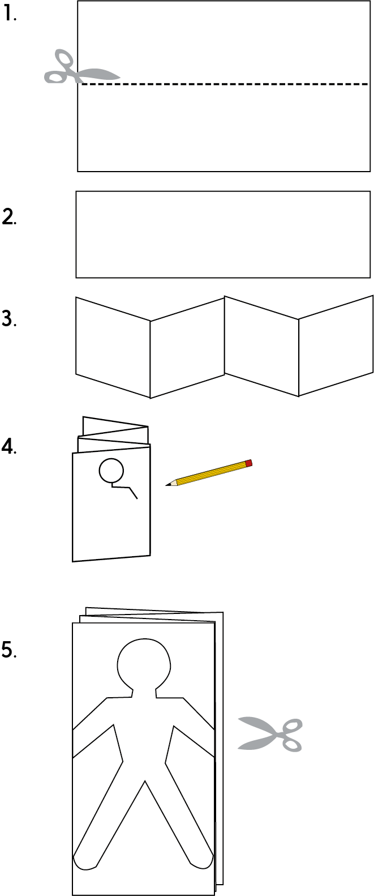
Extension  Change the shape (robots, houses, cats, ice creams, etc.) ensuring that there are points at either side where the picture meets the folds.  Ask your child to draw their own picture or use a template and then you cut around, adding linking tabs.  Try recreating family, friend or story character groups. You could stick on photos of faces or dress. | Questions to ask  Can you help me fold this paper strip?  What shape have we made?  What should I draw if I am drawing a person? Can I fit the whole body onto the fold?  Can you tell me when I get to the hands? I must not cut them.  What do you think it will look like when we unfold it?  These are great outlines. What do you think the people should look like?

Activity 9 – Mark making
Print a rainbow

What to do  - Look at the paint and name the colours. Which ones shall we use today?  - Choose four or five different colours of paint and squeeze them onto the plate or tray in a vertical line.  - Dip the twig in the line of paint.  - Gently press the stick onto the paper to make a colourful printed line.  - Explore what happens if you drag or roll the twig. What if you use the end?  - Repeat the dipping and printing to make colourful patterns and pictures. | What you need  Ready-mixed paint, a large plate or tray, paper, a small flat twig  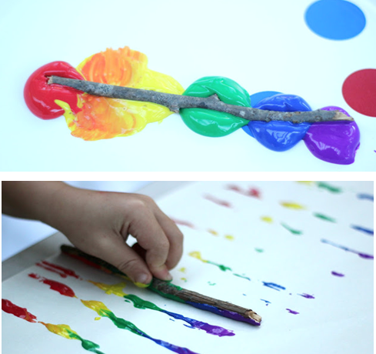
Extension  Use twigs of different lengths/shapes to create a repeating pattern.  Try paint of different shades or white paint on black paper. | Questions to ask  What is your favourite colour? Why is that?  How could we make a pattern using the twig and the paint?  What happens when we roll/drag the twig?  What shape have you made? What is your picture showing?  What happens when the colours get mixed up?

Activity 8 – Paper Craft
Make symmetrical butterflies by folding and cutting
What to do  - Before the activity, make a butterfly shape by folding a piece of paper in half and then cutting out one side of the shape (top wing and bottom wing). Unfold it.  - Show your child the shape. What do they think it is? Can they make it flap? How do they think you made it so that it is the same on both sides?  - Refold the shape and explore it. Can you make a new butterfly shape together?  - Fold a new piece of paper and draw a new butterfly together on one side of the fold (the centre of the butterfly will be along the fold).  - Remind your child how to use scissors safely. Cut out the shape while still folded. Can your child imagine what it will look like when they open it? | What you need  Paper, pencil and scissors  Optional – pens to decorate (or paint)  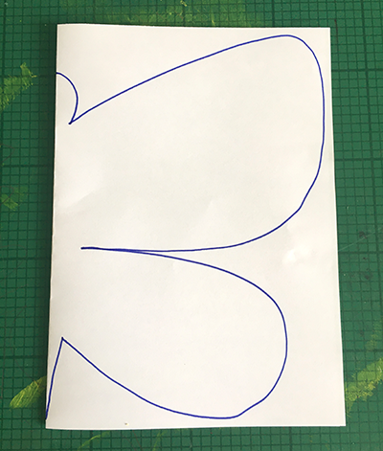  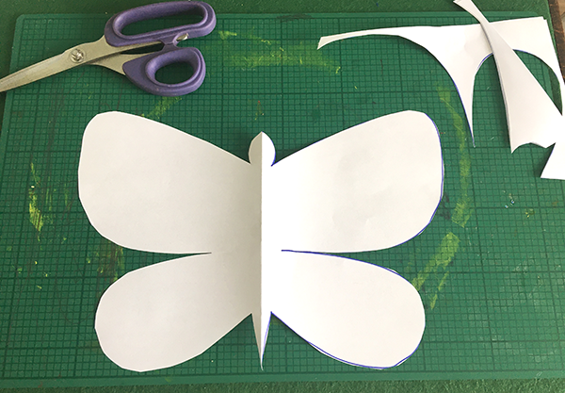
Extension  Decorate the butterflies. If you blob thick paint on one side and fold, you can create a symmetrical pattern.  Explore other symmetrical shapes which can be made by folding and cutting (heart shapes, triangles, rectangles -harder than they look-, ‘gingerbread’ men, stars, etc.). | Questions to ask  How do you think I made this shape? What is the crease for? What happens when we fold it?  Can you see that we have folded the shape in half? – it is the same on both sides.  How could we make a different butterfly?  Can you draw half of the shape?  What will it look like when we unfold the shape?

Activity 7 – Paper Craft
Make a paper plate bird

What to do  - Remind your child how to use scissors safely and how to stick what they have cut out onto paper.  - Explain that they are going to make a bird model. Discuss the different parts of the bird they will need to include (eyes, beak, wings, feet, etc.) and what colours they might use.  - Paint or colour the paper plate and cut out from paper and stick on different features talking about the shapes and colours.  - You could also make some of the features by fixing on buttons, feathers, etc. | What you need  Paper plate, paint or coloured pens, paper & scissors  Optional: paint brush, googly-eyes or buttons, pipe cleaners, coloured feathers  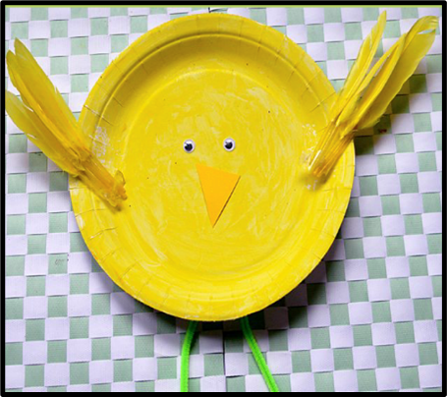
Extension  Make a hole and thread ribbon through it to make a hanging decoration.  Make a bird family, using plates cut to different sizes.  Make different types of bird (e.g. owls, peacocks, robins, etc.)  Make other animals (pigs, cows, sheep, etc.). | Questions to ask  How do we use scissors safely?  How much glue to we need to stick shapes onto paper?  What sort of bird will you make? Is your bird a real one or one from your imagination?  What colour body does it need?  How can we make a beak/wings/feet?  Where shall we out the bird?

Activity 1 – Drawing and painting
Create a self portrait

What to do  - Spend some time exploring what you look like in the mirror. Discuss the different features that you can see, including more subtle features such as eyelids, nostril curves etc.  - Set up paper and any art materials to hand. You may need to help your child draw a face outline large enough to fill the page and position features such as eyes, nose and mouth.  - Work together to look at features in the mirror and to try drawing them  - Plan to present the picture as a gift or part of a greetings card. | What you need  A mirror  Paper and art materials  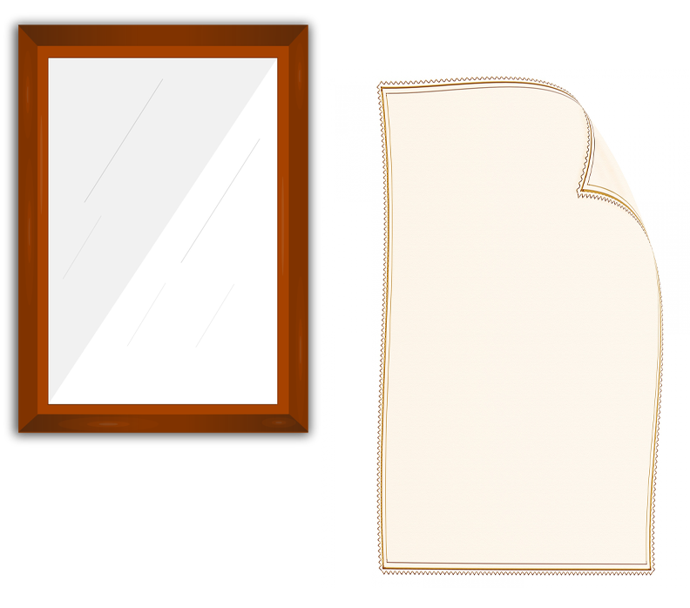
Extension  Send the hard copy or photograph and send to the intended recipient.  Try different media, such as paint, pencils and crayons.  Sit face to face and draw each other at the same time – this can be quite funny. | Questions to ask  What shape is your face? Are you sure it is a circle?  Where is your nose? Is it really in the middle…have another look?  How wide is your mouth? What shape does it make?  How can we get colours which match your hair, eyes and skin?

Activity 2 – Drawing and painting
Draw your home

What to do  - Ask your child to shut their eyes and imagine what their home looks like from the front  - Ask them to draw what they imagined – describe the building they have drawn – is it really like their house?  - Go outside if you can and compare the picture with your home (or use a photo or Google Street View). Compare window numbers, door position and roof shape. What other features can you see?  - Either outside or with a photo, work together to sketch the front of your home. You can add lots of details and colour. | What you need  Paper  Pencils and/or pens  A clipboard or hard back book to lean on  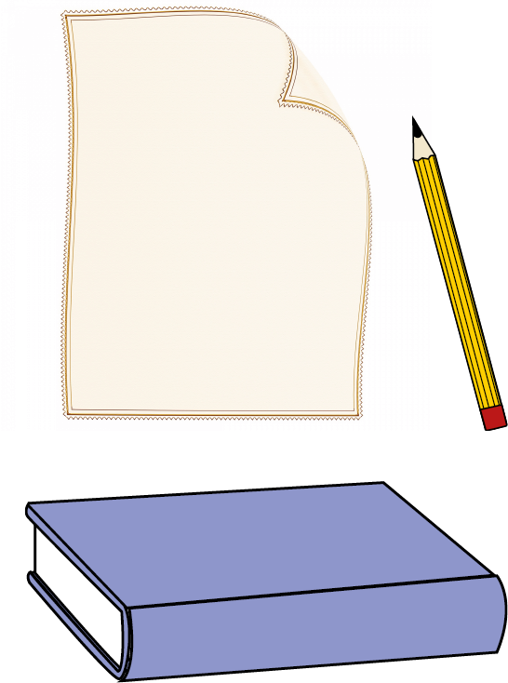
Extension  Draw a different house front which you can see from your window  View a famous building (or family home) which you cannot physically visit using https://www.instantstreetview.com/ (Try Buckingham Palace for example). Draw this building | Questions to ask  Can you shut your eyes and imagine what our house looks like if you stand outside?  How many windows do we have/doors/chimneys?  What shape is our roof?  What other details can you see?  How big are the windows compared to the door?

Activity 3 – Art using natural and found objects
Create an Andy Goldsworthy style picture

What to do  - Collect the items on a walk or over several walks  - Look at some of the images of art by or inspired by Andy Goldsworthy  - Create a picture together by arranging the items – this can be inside or outside – on the ground, paper or on a table etc. Resist fixing with glue or tape.  - Photograph it and explain that you can reuse the things to make as many different pictures as you wish.  - Send images the pictures as gifts or greetings. | What you need  Images of Andy Goldsworthy art and inspired art – see below  Natural objects such as twigs, leaves, pinecones, petals, pebbles, shells, feathers  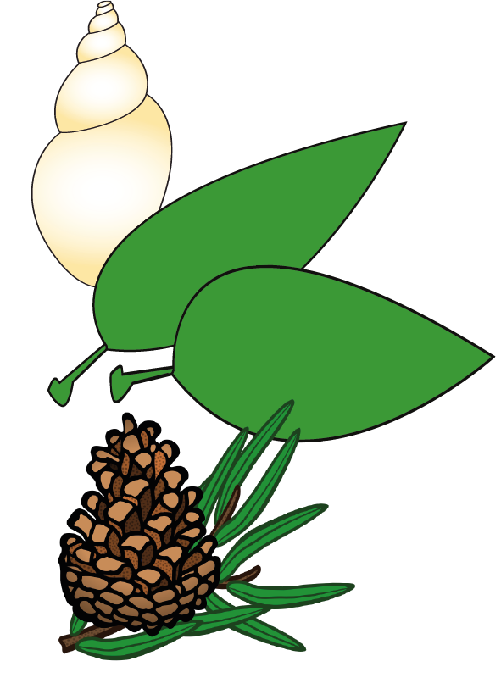
Extension  Introduce the challenge to create a specified effect. Can you make a calm/happy/spooky picture?  Create a gallery of different pictures – involve the whole household. This is accessible at any level. | Questions to ask  What can we find which would make a good picture?  What colours/shapes/textures can you see?  What sort of pattern can you make?  Who are you making your picture for?  How does your picture make you feel?

Andy Goldsworthy Art
https://www.google.com/search?q=andy+goldsworthy&tbm=isch&safe=strict&chips=q:andy+goldsworthy,g_1:artwork:unw-QVNJ_Ls%3D&rlz=1C1CHBF_enGB878GB878&safe=strict&hl=en&ved=2ahUKEwjauJCZt8zoAhUU_xoKHcDuD9sQ4lYoAHoECAEQFQ&biw=1519&bih=722
Activity 4 – Collage
Cutting and sticking from magazines

What to do  - Remind your child how to use scissors safely and how to stick what they have cut out onto the paper.  - Look at some of the pages – discuss the pictures and colours. Talk about the different pictures that they could make by cutting and sticking.  - Remind them that they can try different arrangements and combinations before they stick their shapes in place.  - Let their imaginations run wild. They may want to create an abstract pattern or a picture. They may cut out shapes maintaining the image they are cutting from, e.g. cutting out a car, or they may cut random shapes across images to make new ones. There are no wrong ways to do this! | What you need  Magazines, catalogues or similar  Child-friendly scissor and paper glue  Paper to stick pictures on  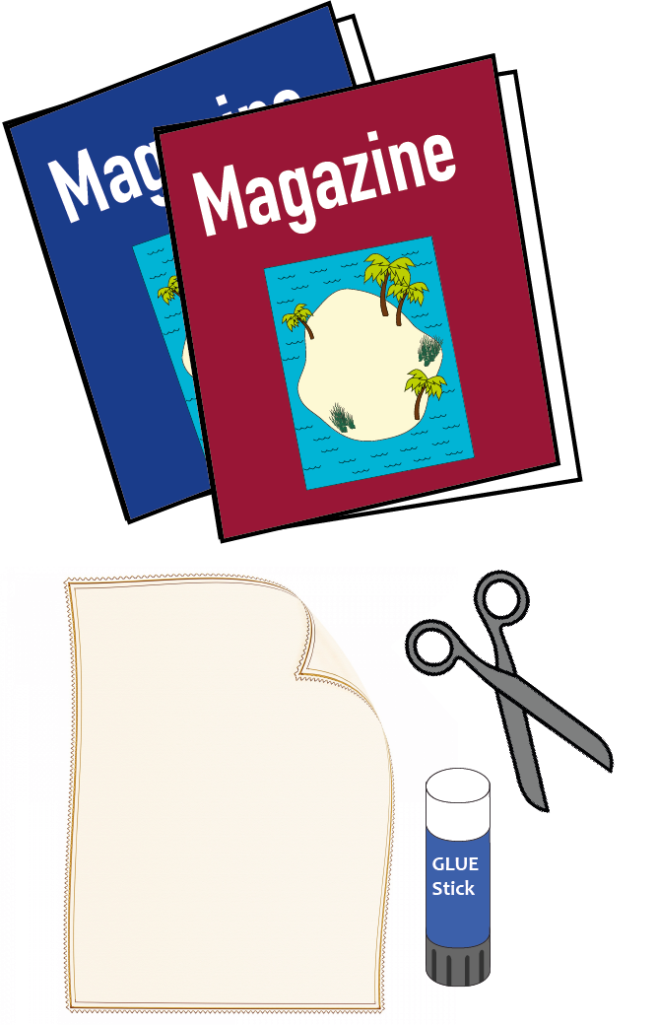
Extension  Provide an outline for children to fill with their cuttings by drawing one on paper in thick pen, e.g. a bed with a patchwork blanket – the cuttings will make the pattern, or a butterfly with open wings – the cuttings with create the wing design, etc.  Challenge your child to use smaller pieces to make numbers, letters or shapes. | Questions to ask  How do we use scissors safely?  How much glue to we need to stick shapes onto paper?  What colours/patterns/shapes can you see?  What are you thinking your picture will look like?  What colours do you need?

Activity 5 – Mark making
Creating leaf, stone, wall and bark rubbings

What to do  - Choose a bumpy surface and talk about the texture. Encourage your child to run their fingertips over it and describe what they feel.  - Demonstrate how to create a rubbing by holding the paper in place on the bumpy surface and rubbing firmly over it with the side of a crayon. Discuss what happens and explore how a light touch doesn’t show on the paper and pressing too hard creates a harsh, uneven effect.  - Explore other potential surfaces to create a rubbing from, allowing your child to explore and experiment.  - Explore different surfaces of the same object, e.g. sides of a leaf. | What you need  Fat crayons with sides exposed (peel off paper wrappers)  Outside textures to rub – leaves, brick/stone wall, trees and any other bumpy surfaces  Paper  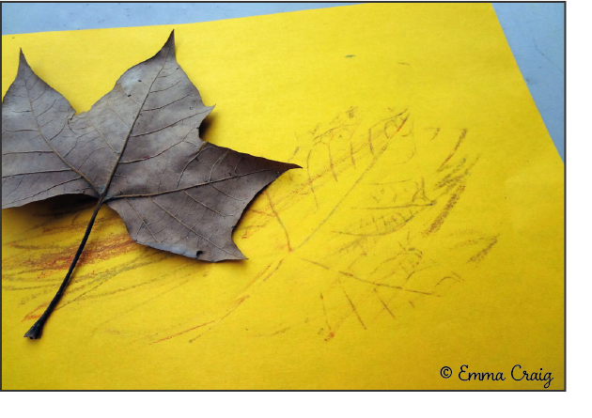
Extension  Try to guess which surfaces created which patterns.  Try different colours, experimenting with layering one rubbing over another.  Cut out some of the rubbings into different shapes to make a picture. | Questions to ask  How could we describe the texture? How does it feel?  What pattern do you think it will make? Shall we test it?  What pattern have we got?  What is the best way to hold the crayon?  What happens if we swap colours?  Do you think the wall will make a pattern?  What will happen if we try the other side?

Activity 6 – Mark making
Take your pencil for a walk

What to do  - Show your child how to take a pencil for a walk, i.e. put the pencil to the paper and begin to draw a randomly moving continuous line, without taking the pencil off the paper until it is covered with lines, swirls and shapes. Explain that you can do this with smooth, curved lines, straight, jagged lines or a mixture of both.  - Allow your child to experiment with the different patterns they can make – they will struggle to keep contact with the paper at first.  - Try colouring the shapes made by the walk. This is most effective with felt-tip pens.  - Try creating tiny or large collaborative patterns. | What you need  A pencil  Plain paper  Pens, pencils, paint for adding colour  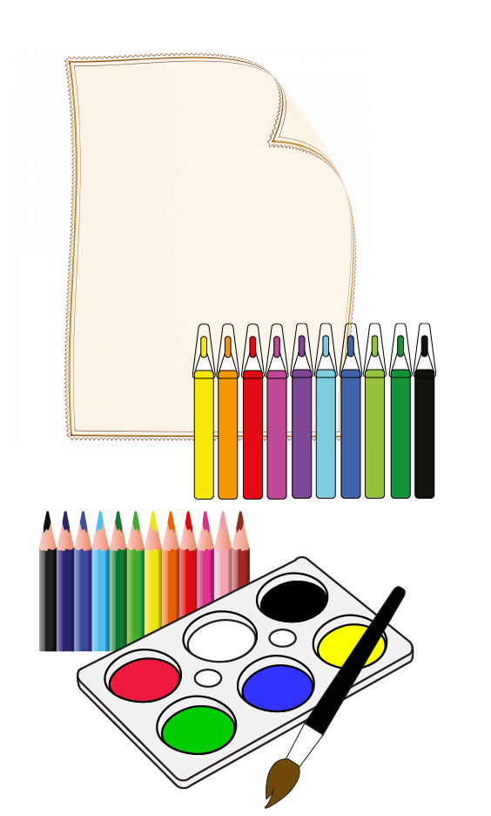
Extension  Dry taking a different thing for a walk, e.g. felt-tip, crayon, chalk, metallic pen on dark paper, etc.  The finished patterns can be cut out to make bookmarks, frames or decorations. | Questions to ask  How do we hold a pencil?  Can you draw a pattern without taking your pencil off the paper?  What patterns have you made?  How could we colour them?  What colours could we use?

